11.97: The change in the volume of the oil is 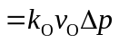and the change in the volume of the sodium is 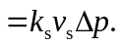 Setting the total volume change equal to Ax (x is positive) and using 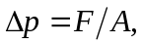
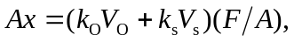
and solving for 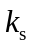 gives
